Piedmont PFHA Trail Horse Test & Clinic
Friday & Saturday, April 24 & 25, 2020 @ 9:00am
T. Ed Garrison Arena, Pendleton, SC
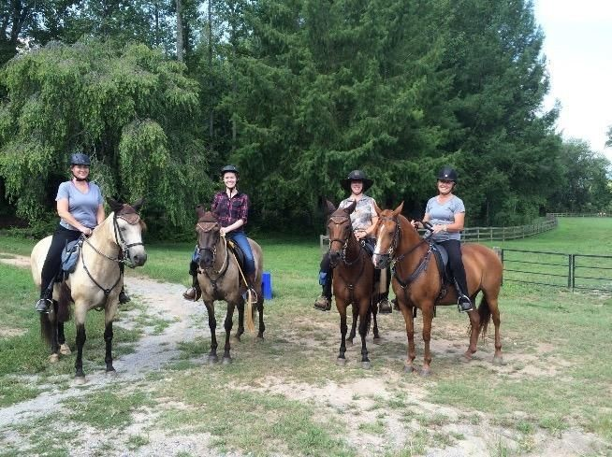

Fees: non PPFHA member: $175.oo
PPFHA member: 150.00
Non member audit: 25.oo
Member audit: free
Stalls: $100 (for all 3 days), includes 3 bags of shavings
(No outside shavings allowed).
Barn dinner Thurs. evening. Lunch included Fri. & Sat. for participants/Auditors $10
RV campsites available
Contact: Holly ​Dake/derbyhorse2@gmail.com/828-216-9497
RSVP by April 11, 2020 $75.00 deposit required with registration.
Updated information at www.piedmontPFHA.org. You can schedule to test either day, with or without doing clinic.

